**Venice Carnival Festival**

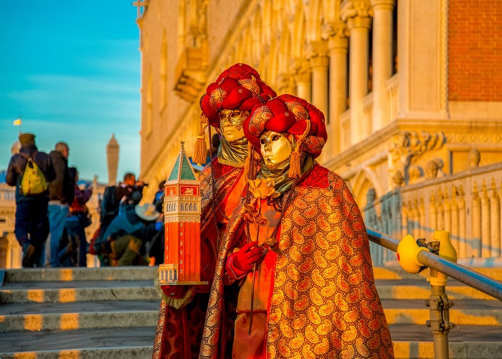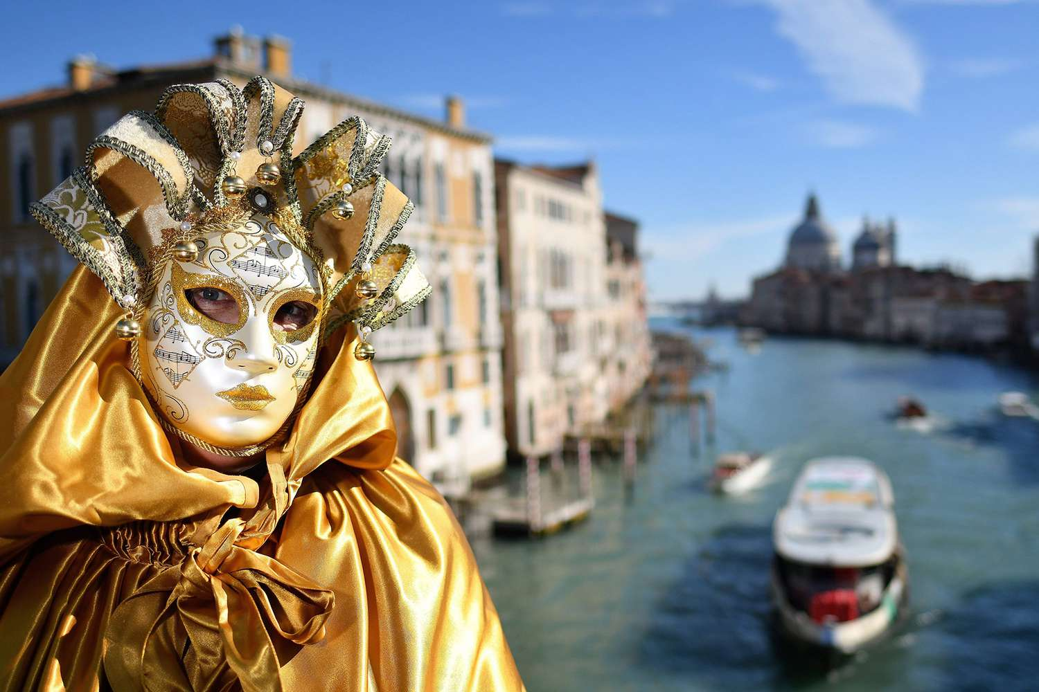What is the Venice Carnival?The Venice Carnival began in 1162 in celebration of the Venice Republic's victory over its enemy: the Patriarch or Aquileia. The people of Venice gathered in Saint Mark's Square (San Marco) to dance and celebrate their victory. Ever since then, the victory was celebrated in the streets of Venice.This is one of the most common questions we get here at Venice Events. The spectacles and pageantry of the carnival are hard to ignore, but outsiders are sometimes confused about why the Venice Carnival is celebrated. The origin of the carnival is extremely removed from its modern reality. The Venice Carnival began in 1162 in celebration of the Venice Republic’s victory over its enemy: the Patriarch or Aquileia. The people of Venice gathered in Saint Mark’s Square (San Marco) to dance and celebrate their victory. Ever since then, the victory was celebrated in the streets of Venice. As time went on, the carnival was celebrated for its own sake and most revellers probably had no idea how it began. It was simply an excuse to have a lot of fun!The Venice Carnival carried on for several centuries until it was outlawed in 1797 while Venice was under the rule of Francis II, the Holy Roman Emperor. Venetians’ use of masks to conceal their identities was also banned at the time. Occasionally, during the 19th century, the festival came back for brief periods, but it was always practised privately, lacking the huge public displays and festivities it’s known for today!Jumping ahead to 1979… the Italian government decided to help Venice reconnect with its festival heritage in order to rejuvenate the culture and economy of Venice. The city’s tourism industry also saw a marked surge of interest. Needless to say, this was a very good idea from the Italian government and the Venice Carnival has grown and grown over the years into one of the world’s biggest and most popular celebrations.